### PROJECT TITLE

**A MINI PROJECT REPORT 18CSC305J - ARTIFICIAL INTELLIGENCE**

***Submitted by***

**MAITREYEE JOSHI [RA2011003011299] TEZASH [RA2011003011317] SHIVESH RAJ [RA2011003011320]**

*Under the guidance of*

**MURALIDHARAN C**

Assistant Professor, Department of Computer Science and Engineering

***in partial fulfillment for the award of the degree of***

**BACHELOR OF TECHNOLOGY**

in

**COMPUTER SCIENCE & ENGINEERING**

of

**FACULTY OF ENGINEERING AND TECHNOLOGY**



S.R.M. Nagar, Kattankulathur, Chengalpattu District

**MAY 2023**

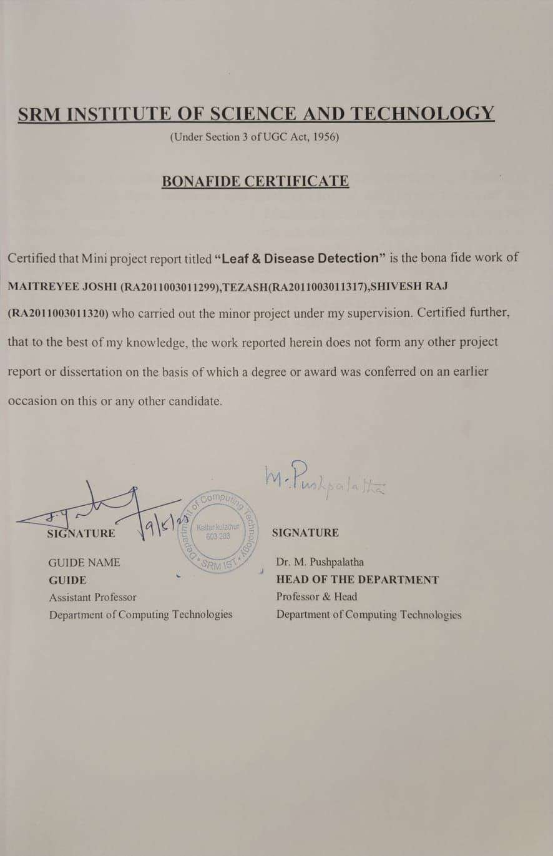

# ABSTRACT

Plant diseases are a global problem that can cause significant damages and losses in crops. To prevent these problems and minimize losses, appropriate measures for disease identification must be introduced. Machine learning and computer vision are actively researched technical approaches that can achieve intelligent farming through early detection of plant diseases. A desirable application would be an aid for farmers or garden enthusiasts to diagnose plant diseases. However, most current applications achieve this function by submitting an image to a team of plant pathologists or expert garden advisers to get possible identification results and advice. Developing a more accessible and convenient application could significantly benefit the agricultural industry.

iii

### TABLE OF CONTENTS

ABSTRACT iii

TABLE OF CONTENTS iv

ABBREVIATIONS vi

1. INTRODUCTION 7
2. LITERATURE SURVEY 8
3. SYSTEM ARCHITECTURE AND DESIGN 9
   1. Architecture diagram of proposed leaf and disease detection 9
   2. Description of Module and components 10
4. METHODOLOGY 14
   1. Methodological Steps 14
5. CODING AND TESTING 15
6. SREENSHOTS AND RESULTS
7. CONCLUSION AND FUTURE ENHANCEMENT 23
   1. Conclusion
   2. Future Enhancement

REFERENCES 24

v

### ABBREVIATIONS

**IOT** Internet of Things

**PCA** Principal Component Analysis

**RGB** Red Green Blue

**YIQ** Luminance-In phase-Quadrature

## CHAPTER 1 INTRODUCTION

Leaf detection is a field of study under the image recognition field of computer vision. Recognizing leaves is of utmost importance in biodiversity conservation. The major project, detection of diseases in leaves, is also another important milestone in conserving not just biodiversity but also saving crops from disease spread. The algorithm PCA has aided the process of leaf detection, by the monitoring of some basic features of leaves and then comparing the values obtained with the available data set. Leaf disease detection is an emerging field that uses computer vision and machine learning techniques to identify plant diseases based on images of their leaves. This approach can provide early detection of diseases, which is critical for preventing their spread and minimizing losses in crop yields. Leaf disease detection has significant potential to aid farmers and agriculturalists in diagnosing diseases quickly and accurately, and providing targeted treatments. The field is still in its early stages, and ongoing research is focused on improving the accuracy and reliability of detection methods, as well as developing new techniques for detecting a wider range of diseases.

## CHAPTER 2 LITERATURE SURVEY

Leaf disease detection is an essential aspect of precision agriculture as it enables early detection of diseases that can significantly impact crop yield and quality. With the increasing demand for food, it is essential to develop effective methods for disease detection to improve crop management practices and reduce economic losses due to disease outbreaks. In recent years, computer vision and machine learning techniques have gained significant attention for leaf disease detection. Feature extraction is a crucial step in this process, where specific characteristics are identified in the image to distinguish between healthy and diseased leaves. Various techniques, such as RGB, HSV, YIQ, and Dithered Images, have been proposed for feature extraction. Among them, RGB color space is widely used as it separates images into their red, green, and blue components, making it easier to identify changes in color intensity that may indicate disease symptoms. The HSV and YIQ color spaces provide an alternative to RGB that can be useful in specific applications**.**

## CHAPTER 3

**SYSTEM ARCHITECTURE AND DESIGN**

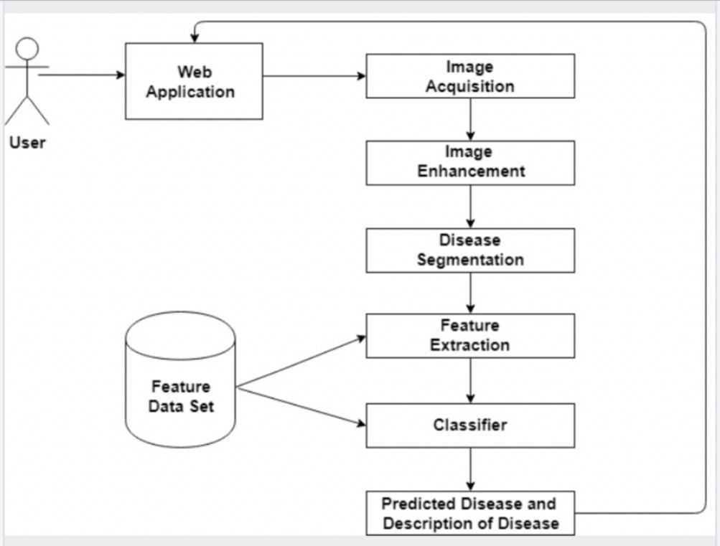

## CHAPTER 4 METHODOLOGY

Data collection: This involves acquiring images of plant leaves that can be used for disease detection. These images can be captured using various devices, such as smartphones or cameras.

Image preprocessing: Before the images can be analyzed, they need to be preprocessed to remove any noise or artifacts that may affect the accuracy of the disease detection algorithm. This can include steps such as cropping, resizing, and color correction.

Feature extraction: This is a critical step in the process that involves identifying specific characteristics in the image that can help distinguish between healthy and diseased leaves. Various techniques, such as RGB, HSV, YIQ, and Dithered Images, can be used for feature extraction.

Disease detection: Once the features have been extracted, a classification algorithm is applied to determine if the leaf is healthy or diseased. Various machine learning algorithms, such as Support Vector Machines (SVM) or Convolutional Neural Networks (CNN), can be used for this purpose.

User interface: The results of the disease detection algorithm are typically presented to the user through a graphical user interface (GUI), which can provide information about the type and severity of the disease.

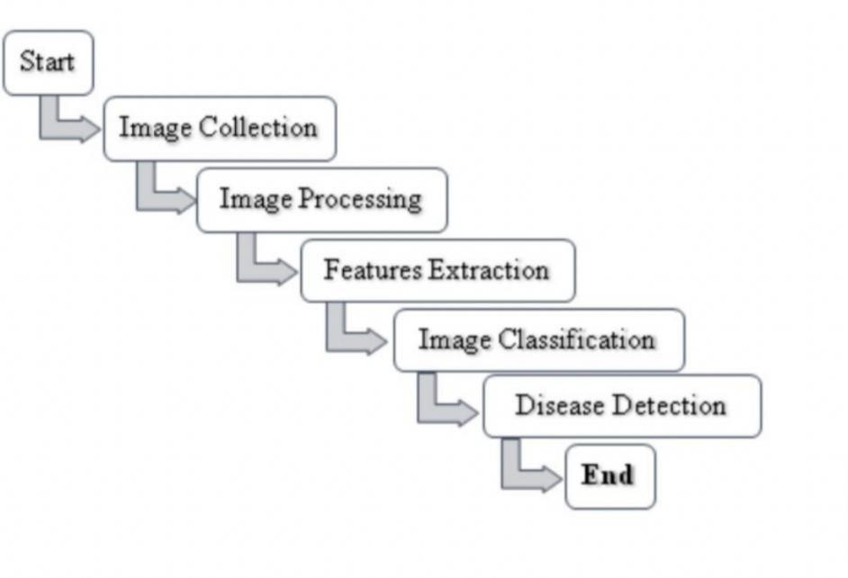

## CHAPTER 5 CODING AND TESTING

import cv2

import numpy as np

import matplotlib.pyplot as plt import numpy as np

import cv2

import matplotlib.pyplot as plt from scipy import ndimage

from sklearn.cluster import KMeans

from sklearn.preprocessing import MinMaxScaler from matplotlib.colors import hsv_to_rgb

img = cv2.imread('./image.jpg') plt.imshow(img)

plt.show()

img = cv2.cvtColor(img, cv2.COLOR_BGR2RGB) plt.imshow(img)

plt.show()

hsv_img = cv2.cvtColor(img, cv2.COLOR_RGB2HSV) plt.imshow(hsv_img)

lower_green = np.array([25,0,20]) upper_green = np.array([100,255,255])

mask = cv2.inRange(hsv_img, lower_green, upper_green) result = cv2.bitwise_and(img, img, mask=mask) plt.subplot(1, 2, 1)

plt.imshow(mask, cmap="gray") plt.subplot(1, 2, 2) plt.imshow(result)

plt.show()

lower_brown = np.array([10,0,10]) upper_brown = np.array([30,255,255])

disease_mask = cv2.inRange(hsv_img, lower_brown, upper_brown) disease_result = cv2.bitwise_and(img, img, mask=disease_mask) plt.subplot(1, 2, 1)

plt.imshow(disease_mask, cmap="gray") plt.subplot(1, 2, 2) plt.imshow(disease_result)



surf = cv2.xfeatures2d.SURF_create(400)

kp, des = surf.detectAndCompute(final_result,None)

len(kp)

## CHAPTER 6 SCREENSHOTS AND RESULTS

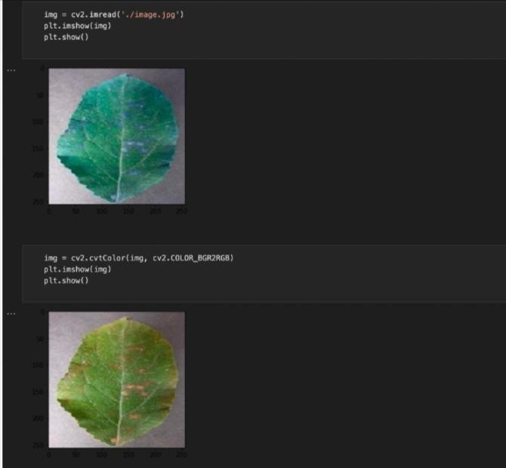

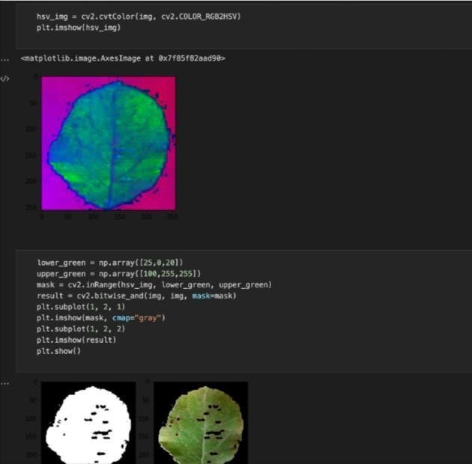

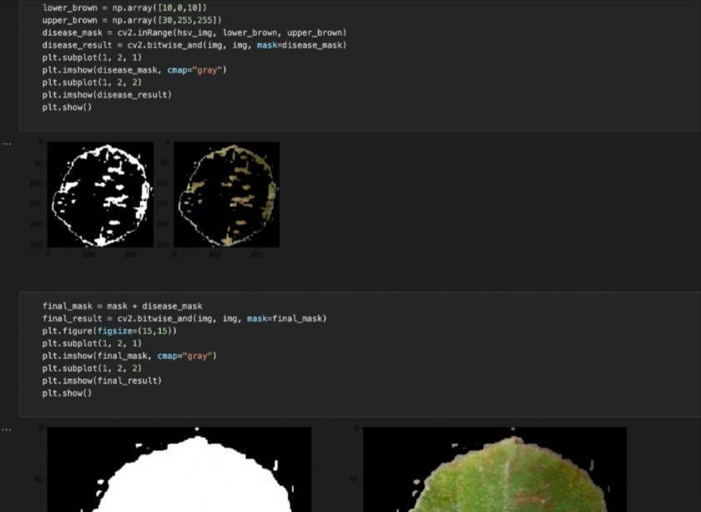

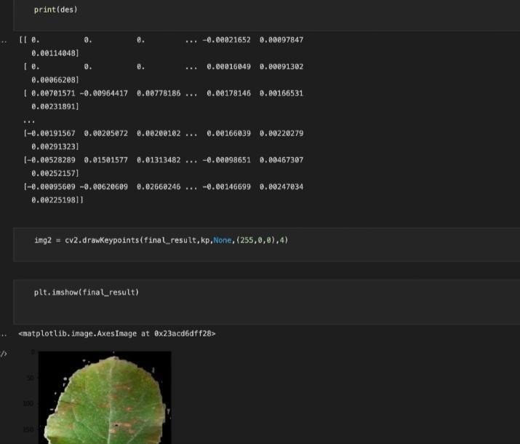

**CHAPTER 7**

## CONCLUSION AND FUTURE ENHANCEMENTS

The goal of the leaf-based plant disease detection project is to achieve an accurate classification of different plant diseases based on their leaf images, with a high level of precision. To accomplish this, the model should be able to generalize well on unseen data and be robust to variations in leaf appearance, such as lighting conditions, background noise, and scale. Additionally, the deployed model should demonstrate efficient inference time and compatibility with different hardware platforms. The project has the potential to contribute significantly to biodiversity monitoring, environmental conservation, and agricultural automation by providing a reliable tool for plant disease identification.

## REFERENCES

* Camargo A. and J. S. Smith. 2008. An image-processing based algorithm to automatically identify plant disease Visual symptoms. Bio.Systematic. Engineering., 102: 9 – 21
* Camargo, A. and J. S. Smith. 2009. Image processing for pattern classification for the identification of disease-causing agents in plants. Com. Elect. Agr.66:121 –125.
* Guru, D. S., P. B. Mallikarjuna and S. Manjunath. 2011. Segmentation and Classification of Tobacco Seedling Diseases. Proceedings of the Fourth Annual ACM Bangalore Conference.
* Zhao, Y. X., K. R. Wang, Z. Y. Bai, S. K. Li, R. Z. Xieand S. J. Gao. 2009. Research of Maize Leaf Disease Identifying Models Based Image Recognition. Crop Modeling and Decision Support. Tsinghuauni.press. Beiging. pp. 317- 324.